Shadowing

* Add a variable to an environment when before you added it, that variable is already in the environment

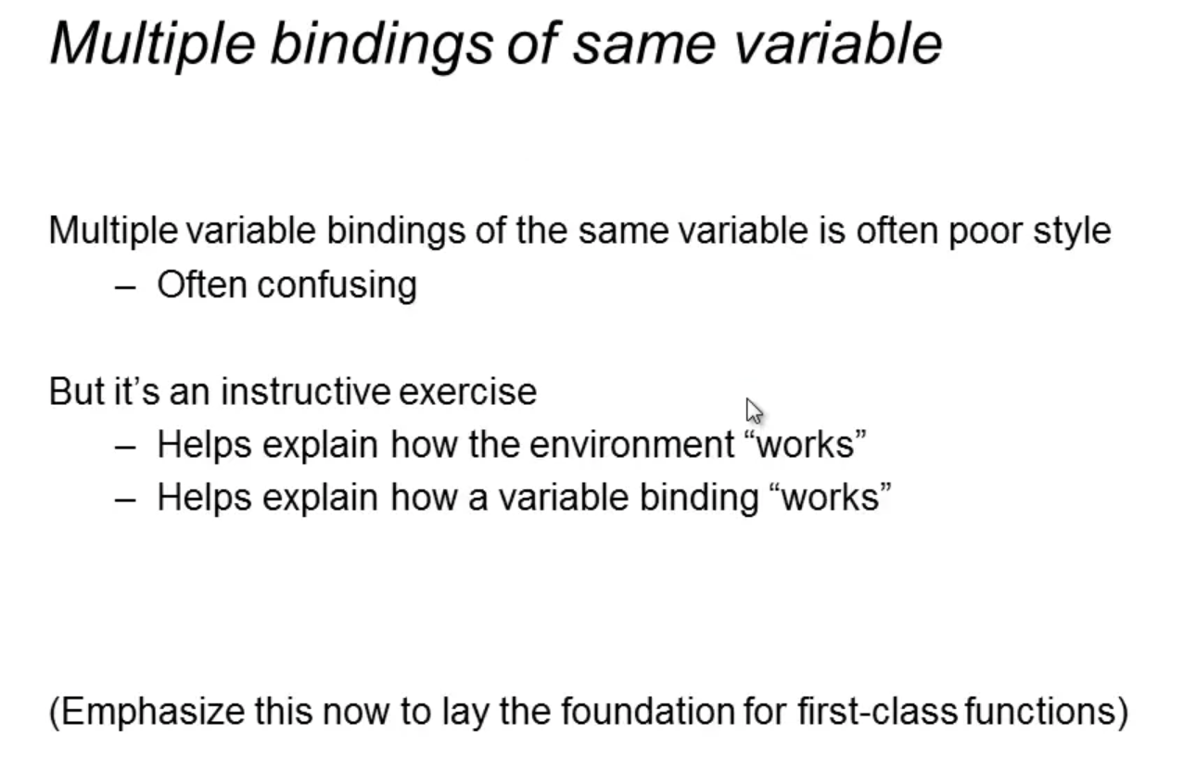

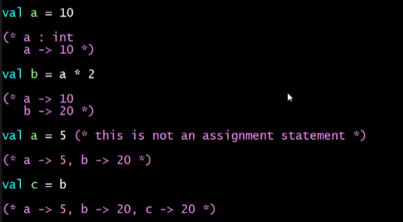

Even if a is again declared as 5, b is not evaluated again, thus b is still 20 then c will be 20 too. There is also no way to reassign or mutate a variable in sml. Only shadowing!

So when you add more expressions after that, a will be mapped to 5



But then when you shadow again “a”

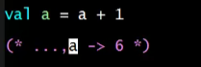

All other expression that will come AFTER this line will use a as 6

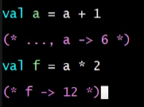

We cannot do this because “f” is not yet declared

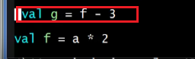

Save and check:

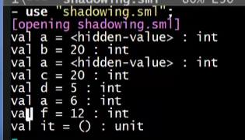

All the shadowed variables’ value are displayed as <hidden-value>

